Report 06

1. **Reflections**

* What was the easiest and hardest part of this assignment?

Easiest part:

Using nested for loops to traverse all pixels and change RGB value is quite easy as long as I understood the methods in the graphics library

Hardest part:

Understand the code and way of use of functions and objects in the external library

The number of parameters can be 3 or 4 since the user can input 1 file or 2 files, and this is difficult to parse parameters in different conditions. Also, have to consider the wrong number or format of arguments and make sure the program will not crash because of any input.

Creating n x n grids is a little difficult since the coordinates need to be carefully checked, it is also achieved by a nested for loop.

* What did you learn?

Nested for loops: especially the terminate condition and its use in an object in two dimensions, such as the pixels of the picture or the matrix grids.

The use of functions graphics library: how to understand the functions, and parameters, different methods such as get width, height, get a pixel, and change RGB, add text, and use them in another py file.

The principle of filter: how an image can be transformed to a filterd image.

Error handling: use try:…except… syntax to catch errors instead of causing termination of the program.

* What is your understanding/definition of a Pixel?

The smallest element of a digital image, the image is formed by numerous pixels, a pixel is a very small grid and each pixel has its own RGB, pixels with different RGB combined together and form a complete image.

* Why do we use nested for loops to process an image?

Nested for loops can iterate through each pixel in an image and make some changes, the outer and inner for loops can treat pixels in width and height directions respectively.

1. **Images**

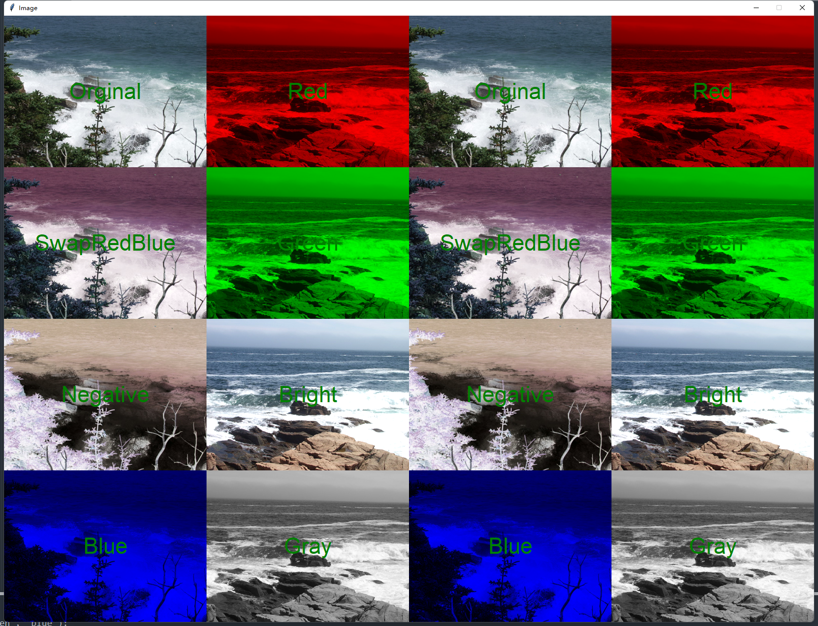

4x4 grid

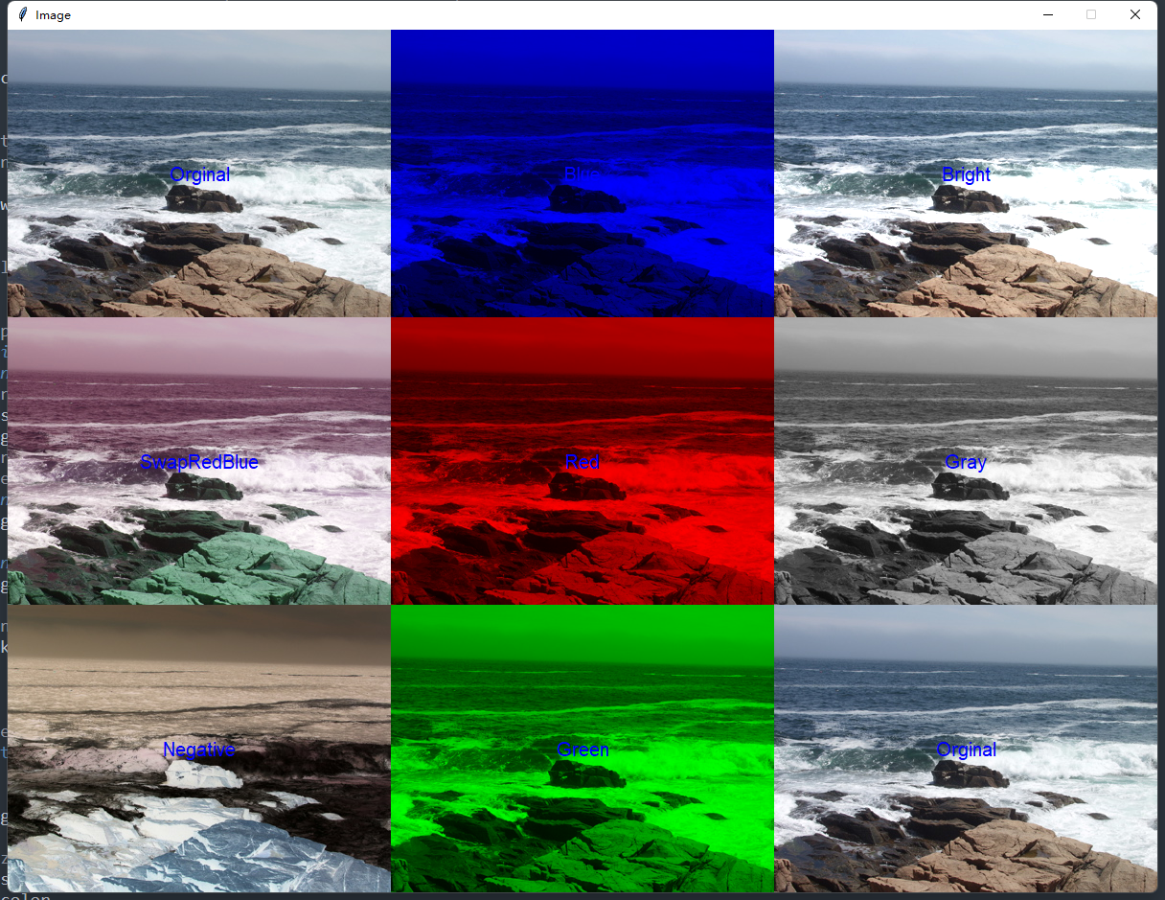

3x3 grid

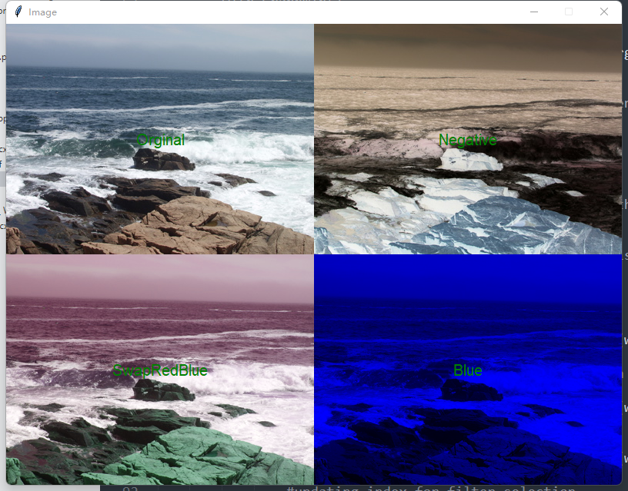

2x2 grid

1. **Extensions**

* **Nested for loops is not only used to change the pixels in images, but also in the n x n grids formation, Create more than squares based on user input, can produce squares such as 2x2, 3x3, 4x4…**

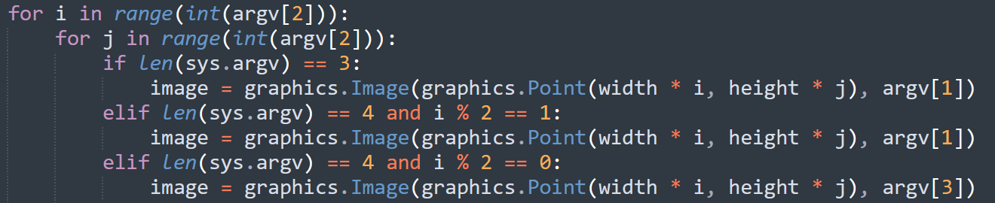

**4x4 Input:**

D:\CS learning\NEU\CS5001\lab_6>**python warhol.py maine1.ppm 4**

In the user input, the third parameter is 4, means draw a 4x4 grids.

**Result:**

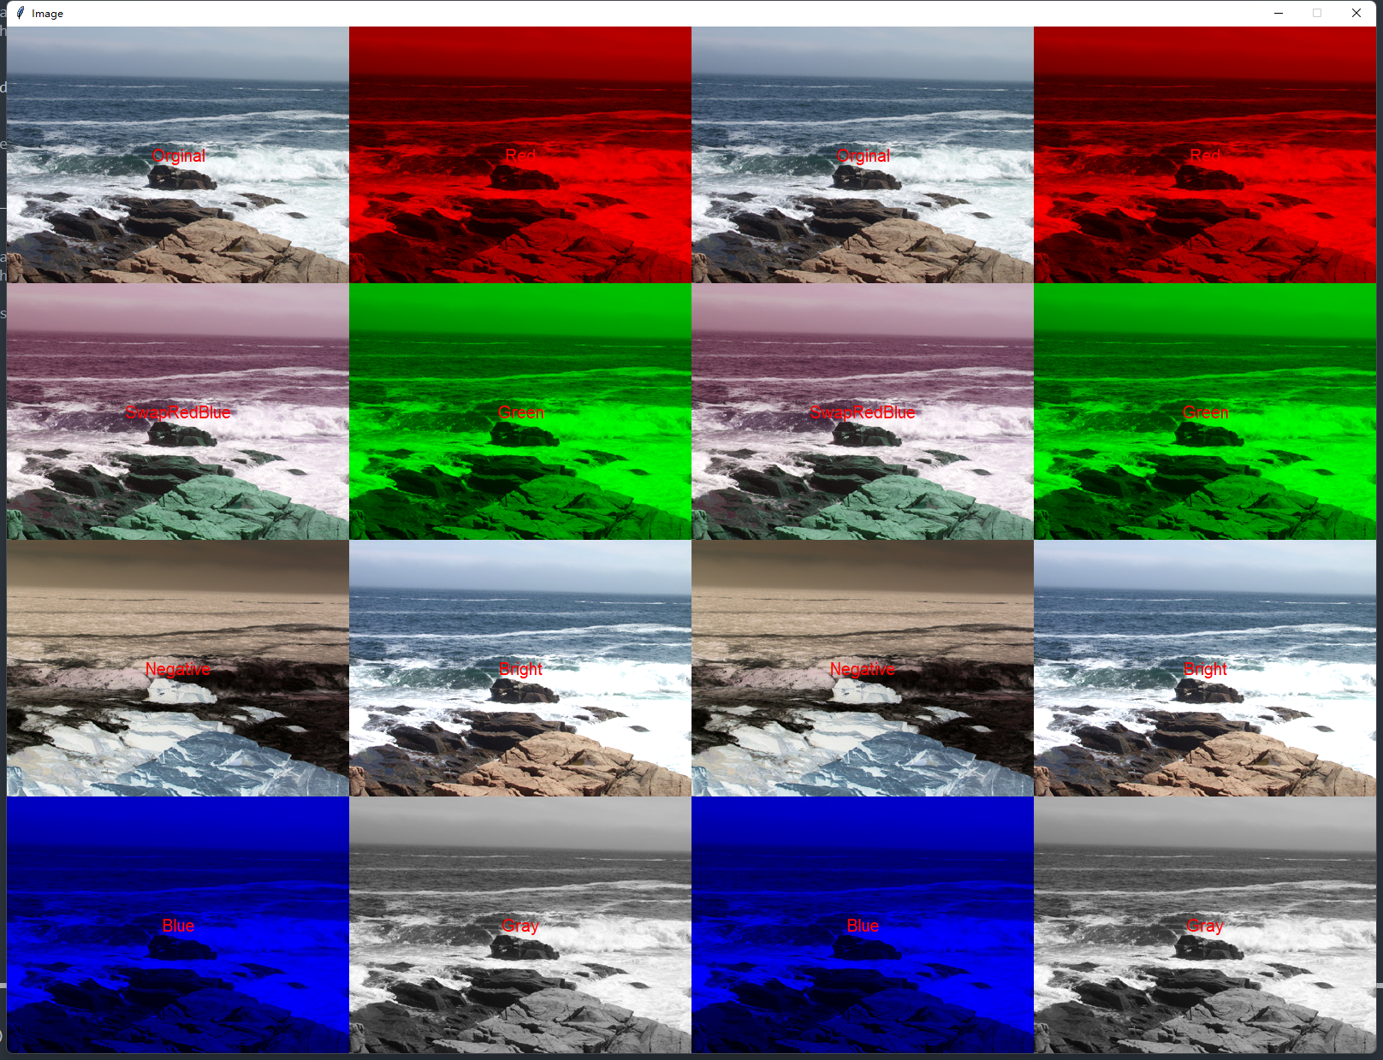

**3x3 Input:**

D:\CS learning\NEU\CS5001\lab_6>**python warhol.py maine1.ppm 3**

**Result:**



**2x2 Input:**

D:\CS learning\NEU\CS5001\lab_6>**python warhol.py maine1.ppm 2**

**Result:**



* **Implemented 8 different image transformations filters**

The 8 image transformations include: orginal, swapRedBlue, gray, negative, bright, blue, red, green

* **Enable the designer to pick the color or size of the text by adding information**

When inputting parameters, there are two input options of text size and text color.

**Input:**

D:\CS learning\NEU\CS5001\lab_6>python warhol.py maine1.ppm 3

**please select text size:**

**15**

**please select color('red', 'green', 'blue'):**

**blue**

**Result:**



If the input is not correct, the program will use the default black color and default size instead of crushing.

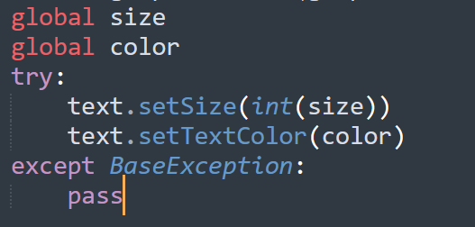

* **Enable it to handle more than one image in the final product**

A fourth parameter can be optionally added, which could enable to addition a second image, and two different images will appear in each column of the grids staggered.

**Input:**

D:\CS learning\NEU\CS5001\lab_6>**python warhol.py maine1.ppm 4 maine2.ppm**

**Result:**



1. **Grading Statement**

The python program includes all of the functions requested in the rubric, runs fine without significant error, and also meets all the requirements in error handling. All extension ideas were implemented except adding shape.

For the above reasons, I think this work deserves a full mark.